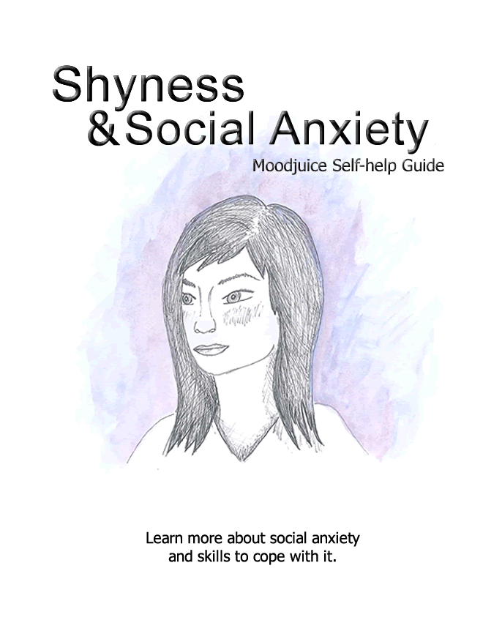
Self Help for Social Anxiety
- Do you feel anxious or self conscious during social situations (e.g. parties; eating in public; or one to one conversations)?
- Do you find it hard to participate in the things you want to because of your shyness?
- Do you tend to avoid speaking to people when you can?
- Do you worry that people think badly of you in social settings?
- Do you worry that you have nothing interesting to contribute to conversations?
- Do you worry that you are the centre of attention and everyone can see how anxious you are?
If the answer to any of these questions is 'yes,' you may be experiencing symptoms of social anxiety and you may find this workbook helpful.
This workbook aims to help you to:
- recognise whether you may be experiencing symptoms of social anxiety.
- understand what social anxiety is, what causes it and what keeps it going.
- find ways to reduce your social anxiety.
Do I have symptoms of social anxiety?
If you are socially anxious, it is likely that you will experience some of the symptoms described below.
Please tick the boxes which describe your feelings, physical symptoms, thoughts and behaviour patterns when in social settings.

Feelings
Anxious / on edge
Vulnerable / under the spotlight
Self conscious / out of place
Embarrassed

Physical Symptoms
Face goes red (blushes)
Butterflies in stomach / stomach churns
Heart races
Voice goes shaky / body trembles
Sweat
Dizzy / light headed
Breathing changes

Thoughts
I have nothing interesting to say, I'm boring
Everyone is staring at me
People can tell how anxious I am
I'll stammer / I'll blush
I mustn't look anxious
I look and sound stupid

Behaviour Patterns
You avoid social situations
You make a quick exit from social situations
You stay in the background or hide away
You stay quiet to not make a fool of yourself
You always take a friend with you
You drink alcohol for courage beforehand
If you have ticked a number of these boxes, you may be experiencing symptoms of social anxiety. However don't be alarmed, this is very common and there are things you can do to help. You will find some useful strategies in this workbook.
What is social anxiety?
Social anxiety is the term used to describe a high level of shyness. Of course everyone feels shy or anxious in certain social environments, but for some people it can be a little more extreme. When this is the case it has a very debilitating affect on their lives and stops them doing the things they would like to. For example it may affect their confidence to go to college or work and impact on their confidence to make friends and enjoy their hobbies.
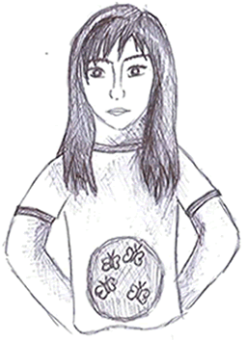
Situations that people often experience social anxiety in include:
- Public speaking
- Talking to authority figures
- Talking to a group of people or an individual
- Eating in public
- Any performance based situations
When in such situations, people can often experience many uncomfortable physical symptoms of anxiety.
These include:
- Butterflies in their stomach
- A rapid heart beat
- Blushing
- Sweating
They often worry that others will notice these symptoms and judge them negatively as a result.
Socially anxious people often feel under the spotlight and believe that everyone is thinking badly of them. They often hold beliefs that they are no good socially, are boring, and that they have nothing interesting to contribute. After social events, they tend to pick out parts that they believe went poorly and 'beat themselves up' over them.
To cope with social anxiety, people tend to avoid social situations if possible (e.g. pubs, canteens, queues etc). If they can't avoid them, they tend to try and stay in the background and attract as little attention to themselves as possible (e.g. say very little).
What causes social anxiety?
Behavioural Explanations:
One theory suggests that we develop social anxiety because of our past experiences. For example, if an infant touched an oven door, the pain from this experience would quickly teach them that oven doors are dangerous and should be avoided in the future. Similarly, it may be that social situations which once posed us no fear were influenced in a similar way. For example, if someone felt embarrassed or humiliated in a previous social situation (e.g. when talking to a small group of people), they may worry that similar situations will go the same way in the future. As a result they begin to fear and avoid them.
Thinking Styles:
Another theory suggests that some people have a thinking style that lends itself to developing social anxiety. For example, socially anxious people are more likely to predict that they will perform poorly in social situations. They also tend to think that everyone is paying close attention to them and scrutinising what they are doing/saying. Socially anxious people also tend to hold negative beliefs about their ability in social situations. For example, they may believe they are boring or have nothing interesting to contribute. Of course, thinking in these ways can lead to high levels of social anxiety.
Evolutionary Reasons:
It is also possible that people develop social anxiety because of evolutionary factors. To understand this, it is worth considering that humans are generally a sociable species who tend to thrive in the company of others. Because of this, it makes sense that people prefer to avoid upsetting others and ultimately being rejected. It therefore seems plausible that socially anxious people are simply slightly over sensitive to being negatively evaluated due to the disadvantages this brings. This could explain why socially anxious people go out of their way not to offend others.
Biological Reasons:
It has also been suggested that social anxiety has familial ties. In other words, if someone in your immediate family is socially anxious, there is a higher chance that you will have similar personality traits. It is therefore thought that our genetic make up plays a role in the levels of social anxiety we experience.
In reality it is likely that a combination of these factors play a role in the development of social anxiety. However, in some ways it is less important to know what causes social anxiety and more important to know what stops us overcoming it.
What prevents us overcoming social anxiety?
Unhelpful Thoughts:
People's unhelpful thoughts and predictions make it more difficult for them to overcome their social anxiety. As discussed earlier, socially anxious people often hold unhelpful thoughts about themselves and their ability in social situations (e.g. I'm dull; I'm weird). This of course lowers their confidence and makes it harder to become involved in social situations. This, in turn, means they rarely get the chance to test out their social skills and prove they can interact well.
Unhelpful thoughts also typically play a damaging role just prior to people entering social environments as they predict they will perform poorly (e.g. I'll have nothing to say). Similarly, unhelpful thoughts influence people during social situations (e.g. I'm making a fool of myself), as they assume they are not coming across well. To make matters worse, after social situations, people often analyse their performance and assume they have performed poorly. When considering these factors, it is easy to see how unhelpful thoughts stop people overcoming their social anxiety.
Avoidance:
As mentioned earlier, socially anxious people tend avoid social contact whenever possible. If they cannot avoid it, they tend to try and escape it as quickly as possible. Although this is a very understandable way of coping with social anxiety, it is actually one of the main reasons that people find it hard to overcome.
This is because by avoiding social situations, people stop themselves having positive experiences that could disprove some of their unhelpful thoughts. Furthermore, the longer someone avoids a social situation, the more daunting it becomes and it is increasingly difficult to face.
Using 'Safety Behaviours':
Often, the only time that socially anxious people feel comfortable in social settings, is when they use what is known as 'safety behaviour'. Examples of 'safety behaviours' include: trying to stay in the background on social occasions; remaining quiet during group conversations; sticking closely besides those they know well; avoiding eye contact or drinking alcohol for extra courage. Basically, a 'safety behaviour' is anything people do to try and make it easier to cope in social situations.
Using 'Safety Behaviours' cont.:
Although such safety behaviours help people feel slightly better at the time, they are actually unhelpful strategies in the longer term. This is because, like avoidance, 'safety behaviours' stop people from having the opportunity to prove that they can cope well, without putting such precautions into place. Instead 'safety behaviours' allow people to put their successes down to other factors (e.g. �I only achieved that because my friend was with me�). Similarly, by remaining quiet during conversations, they never have the opportunity to show that they would have coped well had they became more involved. As a result, people's confidence remains low and their social anxiety remains.
A final point worth noting is that 'safety behaviours' can result in what is known as self fulfilling prophecies. For example, by staying quiet in social situations, people may come across as 'distant' and others may respond by making less of an effort. As a result, their beliefs that they can't mix well remain in place.
Increased Self Focus:
People who are socially anxious often spend a lot of time concentrating on their own bodily sensations during social interactions. Unfortunately, this too plays a part in keeping social anxiety going. For example, people often spend time trying to judge whether they are sweating, stammering, shaking or blushing during social situations. Although they do so in the hope of being reassured that they are not noticeably anxious, this strategy actually just makes things much worse. This is because people tend to overestimate how visible their anxiety is and this of course makes them feel even more self conscious. Also, by focusing on themselves, it means that they are not fully focusing on the conversations going on around them. This makes it more difficult to join in properly and strengthens their beliefs that they are no good in such situations.
It is likely that a combination of these factors play a role in ensuring people's social anxiety continues. See overleaf for an illustration of how these factors can interact to keep our social anxiety going.
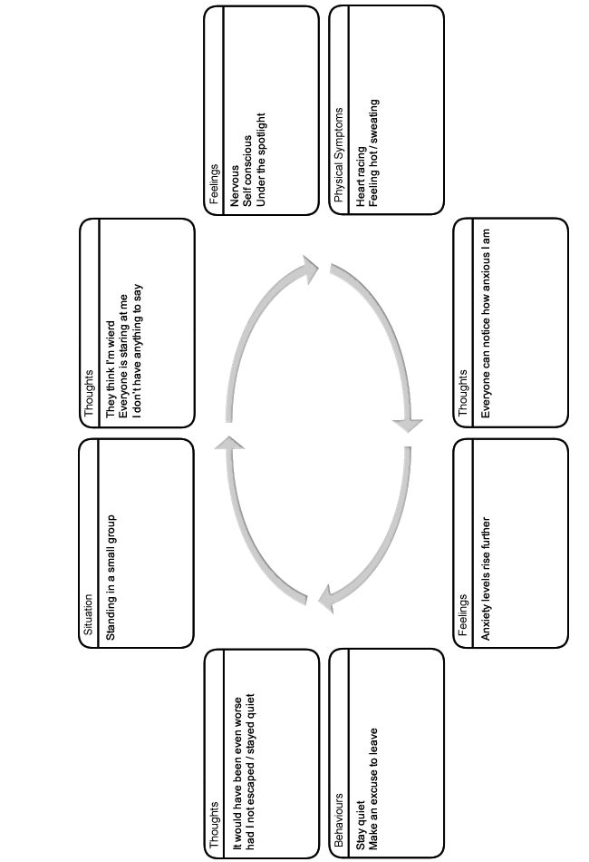
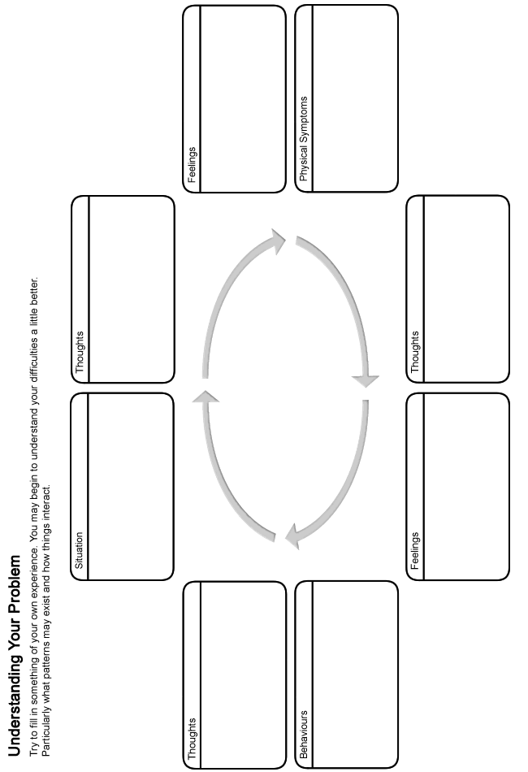
How can I overcome my social anxiety?
Fortunately, there are a number of strategies that we can use to reduce our social anxiety. These include:
- Learning how to challenge our unhelpful thoughts and see things in a more realistic light.
- Reducing our tendency of focusing on ourselves during social interactions.
- Removing the use of avoidance and safety behaviours and gradually confronting our fears.
When going through this booklet it can sometimes be more helpful to try out the ideas above one at a time, rather and trying to learn them all at once. However simply take things at your own pace.
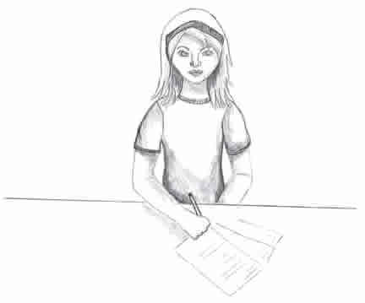
Challenging unhelpful thoughts
The way that we think about things has an impact on our social anxiety. Many of these thoughts occur outside of our control, and can be negative or unhelpful. It is therefore important to remember that they are just thoughts, without any real basis, and are not necessarily facts. Even though we may believe a lot of our unhelpful thoughts when we are socially anxious, it is good to remember that they should be questioned as they are often based on wrong assumptions.
The following section will help you begin to recognise if you are thinking about things in an unhelpful or unrealistic way, and discuss how you can start to make changes to this. By doing so, you can learn to see things in a more realistic light which can help to reduce your social anxiety. You might have unhelpful thoughts about all kinds of things. Here are some examples:
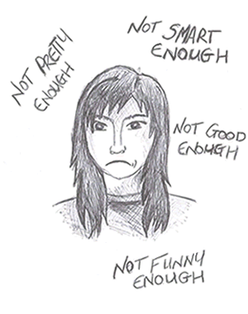
Before Social Situations
- I'll make a fool of myself
- I'll have nothing to say
- I'll go bright red / I'll stammer
During Social Situations:
- Everyone's staring at me
- I'm useless / I'm trembling
After Social Situations
- Everyone thought I was an idiot
- I'd be better off not even bothering
- I sounded like an idiot
About Yourself:
- I'm weird
- No-one likes me
- I'm not very funny
It is clear to see how this kind of thinking might lower our confidence and cause us to feel socially anxious. Do you ever think in any of the ways outlined above? Fill in your examples below:
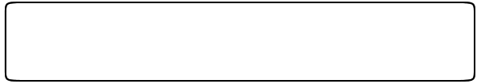You might find it difficult to identify an unhelpful thought. Try thinking about a time when you felt socially anxious. Consider what was running through your mind at that time.
Patterns of unhelpful thinking
First you need to be able to recognise an unhelpful thought. Then you can challenge it. Being aware of the common patterns that unhelpful thoughts follow can help you to recognise when you have them. Here are some of the common patterns that our unhelpful thoughts follow:
Predicting the Future:
When we are shy or socially anxious it is common for us to spend a lot of time thinking about the future and predicting what could go wrong, rather than just letting things be. In the end most of our predictions don't happen and we have wasted time and energy being worried and upset about them. For example:
- You worry that you will go red, stammer, and that everyone will dislike you.
- You assume that you will be the centre of attention and everyone will stare at you.
These thoughts naturally make you anxious before you even arrive in a social situation.
Mind Reading:
This means that you make assumptions about others' beliefs without having any real evidence to support them. For example:
- He thinks I'm an idiot.
- They think I look ugly.
Such ways of thinking can soon lower our mood and self-esteem.
Taking Things Personally:
When people are socially anxious or shy, they often take things to heart. For example:
- Because a work colleague is quiet, you assume you have offended them and it is somehow your fault.
- You walk past a group who are laughing and assume the joke is at your expense.
Over Generalising:
Based on one isolated incident you assume that all others will follow a similar pattern in the future. For example:
- Because you believe that one presentation went badly, you assume all others will follow the same pattern, as opposed to seeing it as a one off.
What If Statements:
Have you ever wondered "what if" something bad happens? For example:
- What if nobody likes me?
- What if I run out of things to say?
These thoughts also make you dread situations beforehand.
Focusing on the Negatives:
After a social gathering, you tend to focus on the parts of the evening that you believe didn't go well. At the same time, you gloss over positive parts of the evening. For example:
- You dwell on the one conversation which ran out of steam quickly, whilst forgetting the fact that you mingled well throughout the rest of the evening.
Labelling:
Do you saddle yourself with negative labels? For example:
- I'm boring.
- I'm uninteresting.
- I'm weird.
- I'm unlovable.
These, often long held beliefs about yourself, ensure your confidence and self-esteem remains low.
Do any of your unhelpful thoughts follow some of these patterns? Jot down any examples you can think of into the box below:
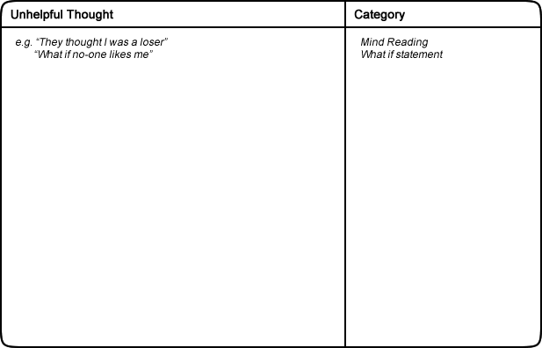
We can learn techniques to challenge these unhelpful thoughts. This can help to reduce your social anxiety. The next part of this handout will discuss how we can go about challenging our unhelpful thoughts. You may come up with a more balanced thought that is accurate and based on evidence.
How to challenge unhelpful thoughts
Once you have recognised an unhelpful thought the next stage is to challenge it. To do this, you can ask yourself a serious of questions. See the example below:
Situation: You are due to meet your friend's work colleagues.

How you feel: On edge, self conscious.
Unhelpful thought: I'll have nothing to say and they'll think I'm an idiot!

Challenges to an unhelpful thought
Now you can challenge your unhelpful thoughts by asking these questions.
Is there any evidence that contradicts this thought?
- I coped fine last week when I was introduced to my brother's new partner.
- I never run out of things to say to my friends, so why should this be different.
Can you identify any of the patterns of unhelpful thinking described earlier?
- I'm predicting the future. I'm imagining that it'll go badly but I can't say for sure how it will go.
What would your friend say to you if they knew what you were thinking?
- They would probably say - don't be silly, you're always good company.
How will you feel about this in 6 months time?
- I probably won't care. Even if it goes wrong I'll have forgotten about it by then.
What are the costs and benefits of thinking in this way?
- Costs: It's making me nervous before I even go into the situation. It's made me feel inadequate.
- Benefits: I can't really think of any.
Is there a another way of looking at this this situation?
- Even if I don't have anything to say, it's not just up to me to keep conversations going. It's everyone's responsibility.
Once you have asked yourself these questions, you should read through your answers. Try to come up with a more balanced or rational view. For example:
I can't say for sure how it will go. I coped fine last week in a similar situation so hopefully this will be the same. If it doesn't go great it's not the end of the world.
Try to apply these questions to the unhelpful thoughts that you notice. It can help to reduce your social anxiety. You can use this technique to test your thoughts are realistic and balanced.
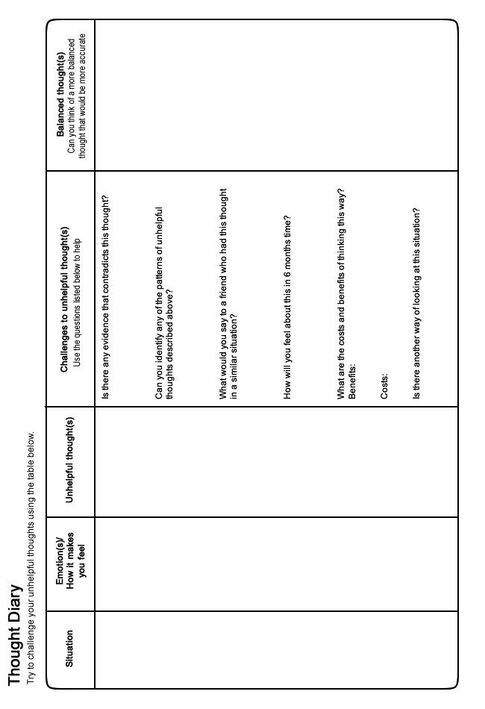
Reducing internal focus during social interactions
When we are socially anxious, we tend to spend a lot of time concentrating on our own bodily sensations during social interactions. This is because we fear that our anxiety is visible to others. For example, we may spend time trying to judge whether we are sweating, shaking, or blushing.
Although we do this in the hope being reassured that we are not visibly anxious, this strategy actually just makes things much worse. This is because we tend to overestimate how visible our anxiety is and this of course makes us feel even more self conscious. Also, by focusing on ourselves, we are prevented from fully concentrating on the conversations around us. This naturally makes it more difficult to join in properly and we usually end up interacting less well than we could. This typically strengthens our beliefs that we are no good in such situations. The reality is that anxiety is a lot less visible than we think. Often we have no idea if someone is anxious or not and it can help to remember this.
Similarly, when we feel socially anxious, we tend to spend time monitoring how well we are performing during social interactions. This too prevents us from paying proper attention to the conversations we are engaged in. For example, we may spend time trying to figure out if our voice sounds shaky, or go over and over the things we have said in our minds. Again, by doing so, we end up finding it hard to follow conversations which likely makes us perform worse. Given all of this, it is helpful to try to remove this tendency to focus on ourselves. Below you will find tips designed to help you during social interactions:
- Try to spend less time focusing on your own physical symptoms in social situations.
- Remember anxiety is much less visible than you imagine.
- Even if you are visibly anxious, it does not necessarily mean that you will be thought badly of. Anxiety is something we all experience and it does not make you unusual.
- Just because you feel anxious, it does not mean that you are performing poorly.
- Remember - you are not the central focus of everyone's attention. There are plenty of other things for people to think and talk about.
- Really try to concentrate on the conversation you are involved in. Don't think about how you appear or how well you are performing.
- Don't replay parts of the conversation in your mind, instead just focus on what is being said in the present moment.
- We do not need to perform perfectly or brilliantly in every social interaction we have, no-one can achieve such high standards.
- Don't worry too much if there are silences. Everyone has a responsibility to keep conversations going. Besides, silences are ok and do not always need filled.
- Just be yourself - don't 'put on a front.' Why bother when it is impossible for everyone to like us anyway.
The next section discusses how we can begin to gradually confront the situations we have tended to avoid. Try to put these tips into practice whilst you do so.
Removing the use of avoidance and safety behaviours
When we are socially anxious, we tend to avoid social situations (e.g. parties; speaking in front of small groups, asking for a refund etc). However if we keep avoiding the situations we fear, we never get the chance to prove to ourselves that we can cope in them and our confidence remains low. Similarly, whenever socially anxious people do enter the situations they fear, they tend to use 'safety behaviours' (e.g. sticking tightly besides a good friend at a party; staying silent when in a small group to avoid looking foolish etc). Although these behaviours seem to help in the short term, upon closer inspection they are actually unhelpful. This is because they stop people from learning that they could have coped fine without relying on such precautions. Instead, someone may believe: "I only coped during that party because I had my best friend besides me" so their confidence remains low. Therefore, like avoidance, safety behaviours stop us from learning that we can cope in such situations and our anxiety towards them continues.
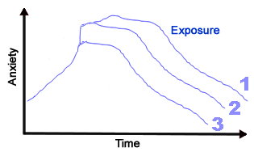
Because of this, the best way to reduce our anxiety towards social situations is to gradually confront them, without relying on safety behaviours. Of course, confronting social situations can be daunting, especially given that our anxiety levels often rise when we do so. However research shows that if we can stay in a situation that we feel anxious in for long enough (without using our safety behaviours), gradually our anxiety will reduce. It is almost as though our body and mind become 'used to' the situation and our anxiety begins to fall. This may take around 30 minutes or more but often happens more quickly. More importantly, if we subsequently confront a similar situation again, the amount of anxiety we experience is likely to be less and less on each occasion. Not only this, but it is likely to pass more quickly each time too, until the point that the situation causes us little or no anxiety. Take the exmaple below:
Someone who was anxious about spending time in the town centre because they feared that everyone would stare at them.
- They made themselves go to the town centre and stay there until their anxiety reduced.
- They then repeated that task everyday that week. Their anxiety became less and less each time they did so as their confidence grew.
Of course, not all the scenarios we fear last very long (e.g. having a brief chat with your neighbour in the street). But again, if you repeatedly allow yourself to become involved in a short conversation, rather than avoid it, you can begin to prove that you can handle these scenarios much more effectively than you think and your confidence will soon rise. Having said this, confronting social situations may still be a daunting thought. Fortunately the 5 steps described next can help to make this more manageable.

Step 1 - Generating ideas for your exposure hierarchy
As confronting social situations can sometimes be a daunting thought, it can be helpful to do so in a gradual way. Creating an exposure hierarchy can help you to do this. An exposure hierarchy is basically a list of social situations which would cause you varying degrees of anxiety (see the example below). The idea is that you confront the easiest (or least anxiety provoking) item on your hierarchy to begin with and work your way through to more difficult items as your confidence grows.
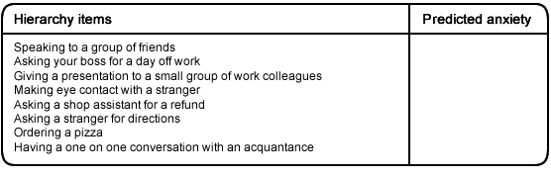
Use box 1 on page 22 to list items for your hierarchy. Don't worry about ranking the order of items at this stage. To help you get ideas for your hierarchy, it may help to consider all the social situations and scenarios that:
- Make you anxious
- You avoid or escape from
- You only confront if you are using a 'safety behaviour'
It is important that the items on your list cause you varying degrees of anxiety (e.g. speaking to a small group of friends versus a group of work colleagues). This will allow you to begin work on overcoming your fear starting with 'easier' items on your hierarchy.
Step 2 - Ranking your hierarchy
Once you have a list of items for your hierarchy, the next stage is to try to rank them in order of least anxiety provoking to most anxiety provoking. To help, try to predict how anxious you believe each item would make you feel on a scale from 0 to 100, where 100 is the most anxious you have ever felt and 0 is the most relaxed you have ever felt (use box 2 on page 22). Once you have completed this, rearrange the items on your list from least anxiety provoking to most anxiety provoking (use box 3 on page 22). For example:
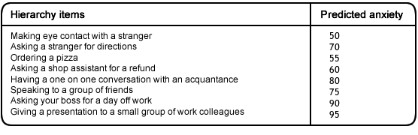

Step 3 - Confronting the first item on your hierarchy
Once you have finalised your hierarchy, the next step is to confront the first item on it as soon as possible (this is often referred to as an exposure task). This should be the item that you predict will cause you the least amount of anxiety from your list. During exposure tasks it is important to:
- Remember that although your anxiety will initially rise during an exposure task, it will fall if you remain in the situation for long enough.
- Be aware that anxiety is a natural and healthy reaction that everyone experiences. Although it can feel unpleasant, it is not dangerous and will gradually pass if you remain in the situation for long enough.
- Try to remain in the situation until your anxiety reduces by at least half. For example, if your anxiety rises to 50 during an exposure task, you should remain in the situation until it reduces to 25 or (preferably) less. The amount of time this takes will probably vary from task to task. It may take anything up to 30 - 45 minutes, but commonly happens much more quickly. Note: depending on the nature of the social situation, it may not be possible to remain in it for a long period of time (e.g. saying hello to a stranger, talking to a neighbour on the way to your car). This is absolutely fine. Although your anxiety may not have enough time to rise and fall naturally, you will still be able to take confidence from that situation if it goes well, which should make you more comfortable in similar situations in the future.
- Remember that anxiety is not as noticeable as you think.
- Avoid using any safety behaviours as they simply slow down your progress. If it is too hard to remove them all at once, try to gradually reduce them over time.
- Try to focus on the conversations and people around you. Avoid focusing on your own performance or what other people may be thinking.
- It may also be helpful to try to challenge any unhelpful thoughts you have about that social situation before you do so (see section 1).
It is also worth considering that not all social situations you become involved in can be predicted beforehand. Because of this it will likely be impossible to follow your hierarchy exactly (e.g. a stranger may approach you with a question before you feel ready for this step). However, this is absolutely fine. Should you find yourself in a situation earlier than you would have liked, simply do your best and try and remember some of the tips from section 2. It may also be difficult to arrange or 'set up' certain situations on your hierarchy (e.g. speaking to a group of people). So you may have to be opportunistic and look out for opportunities presenting themselves.

Step 4 - Repeating the exposure task
Once you have completed your exposure task once, the next step is to do so again, over and over, as often as possible, until the situation no longer makes you feel anxious. You should find that each time you confront the item on your hierarchy, it will become slightly easier. As a rule of thumb, try to ensure that you engage in your exposure task everyday if you can. Remember that the more often you expose yourself to an item on your hierarchy, the quicker you will overcome your fear towards it.

Step 5 - Moving onto the next item on your hierarchy
Once you have overcome your fear towards the first item on your hierarchy, you should follow the same steps with the next item on your hierarchy. Continue through your hierarchy in this manner until you have reached the top and feel more confident about social situations.
Remember that as you progress through each stage of your hierarchy your confidence will grow. This should mean that items which are higher on your hierarchy - that seemed very daunting at first - will be less frightening when you actually come to face them because of your previous achievements.
Trouble shooting:
- If you attempt an exposure task and it does not go as well as you had hoped - try not to worry as this can happen from time to time. Try again as soon as you can.
- If the exposure task still seems too hard, see if you build in an extra step or two before it on your hierarchy. This will allow your confidence to grow further before facing it. For example:
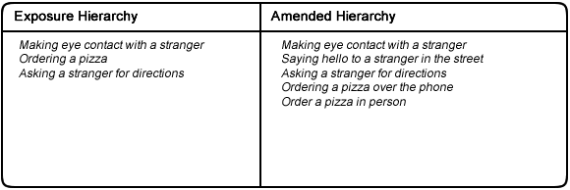
- If you find that your anxiety is not reducing during an exposure task - ask yourself:
  - Are you using a 'safety behaviour' which is preventing you from fully confronting your fear?
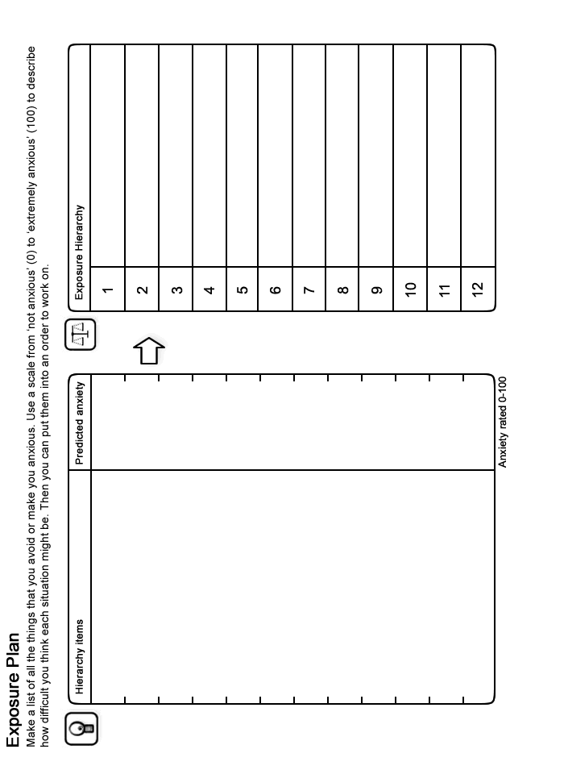
Final Word
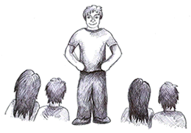
We hope that you found some of the ideas in this booklet useful. You can continue to use the techniques you found helpful long into the future and they should continue to benefit you. If some of the ideas are not particularly helpful at first, it is perhaps worth sticking with them for a few weeks to give them a chance to work. If however you feel your situation remains largely unchanged or if you did not find this booklet useful, you should speak to your GP who can tell you about the other options available which you could find helpful.
Further Information and Resources
For further information and self-help resources go to Moodjuice online:
http://www.moodjuice.scot.nhs.uk
Moodjuice is a website designed to offer information and advice to those experiencing troublesome thoughts, feelings and behaviours. In the site you can explore various aspects of your life that may be causing you distress and obtain information that will allow you to help yourself. This includes details of organisations, services and other resources that can offer support. This self help guide comes from a series that you can access and print from Moodjuice. Other titles available include:
- Depression
- Anxiety
- Stress
- Panic
- Sleep Problems
- Bereavement
- Anger Problems
- Social Anxiety
- Phobias
- Traumatic Stress
- Obsessions and Compulsions
- Chronic Pain
Some Useful Organisations
The following organisations or services may be able to offer support, information and advice.
Samaritans
Samaritans provides confidential emotional support, 24 hours a day for people who are experiencing feelings of distress or despair, including those which may lead to suicide. You don't have to be suicidal to call us. We are here for you if you're worried about something, feel upset or confused, or you just want to talk to someone.
Phone:
116123

Web Site:
http://www.samaritans.org
Anxiety UK
National charity established in 1970 to provide support and services to those suffering from all anxiety disorders, obsessive compulsive disorder, generalised anxiety disorder, panic attacks, social phobia, simple phobia, phobia and tranquiliser issues.
Phone:
08444 775 774

Web Site:
http://www.anxietyuk.org.uk/
Breathing Space
Breathing Space is a free, confidential phone line you can call when you're feeling down. You might be worried about something - money, work, relationships, exams - or maybe you're just feeling fed up and can't put your finger on why.
Phone:
0800 83 85 87

Web Site:
http://www.breathingspacescotland.co.uk
Living Life to the Full
Living Life to the Full is an online life skills course made up of several different modules designed to help develop key skills and tackle some of the problems we all face from time to time.
Web Site:
http://www.llttf.com/

